**PyCity Schools Summary and Analysis**

**Background**

The purpose of this project is to analyze the district-wide standardized test result of math and reading. There are 15 schools and a total of 39,170 students, from grade 9th to 12th, in this dataset. We would like to see the trends in school performance so that we can make strategic decisions regarding school budgets and priorities**.**

**District Summary**

There are 15 schools and a total of 39,170 students in this dataset. The average math and reading score of the students are 78.985 and 81.877 respectively. The percentage of students who passed math (score is greater than or equal to 70) is 74.98%, while the percentage of student who passed reading is 85.80%. The percentage of students who passed both math and reading is 65.17%.



**School Summary**

There are 7 district schools and 8 charter schools in this dataset. The number of students in schools range from 427 students (Holden High School) to 4,976 students (Bailey High School). All district schools are large school size (2,000 – 5000 students), while the charter schools are medium size (1,000 – 2,000 students) and small size (< 1,000 students).

District schools have a total school budget higher than charter school. Bailey High School is the district school with the highest school budget of $3,124,928 and Holden High School is the charter school with the lowest school budget of $248,087. The school budget was allocated to district schools more than charter schools; this is probably due to the size of district schools that they are larger than charter schools. Total budget for district schools is $17,347,923 and the total budget for charter school is $7,301,505.

Below is the table that summarizes key metrics for each school.

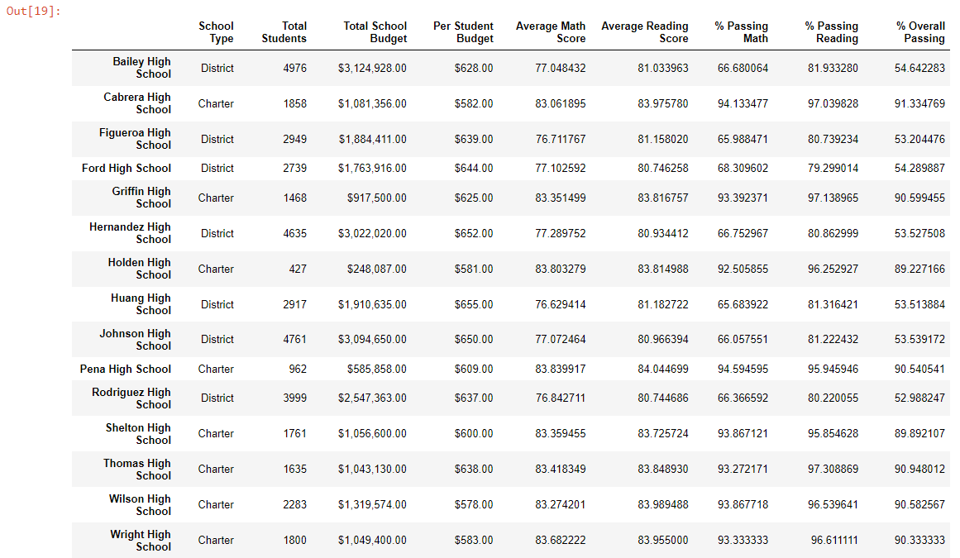

**Observable School Performance**

1. **Highest-Performing School (by % Overall passing)**

The table below shows the top 5 in highest performing schools, which are all charter school type. All 5 of the top performer schools have 90% or more in overall passing rate.

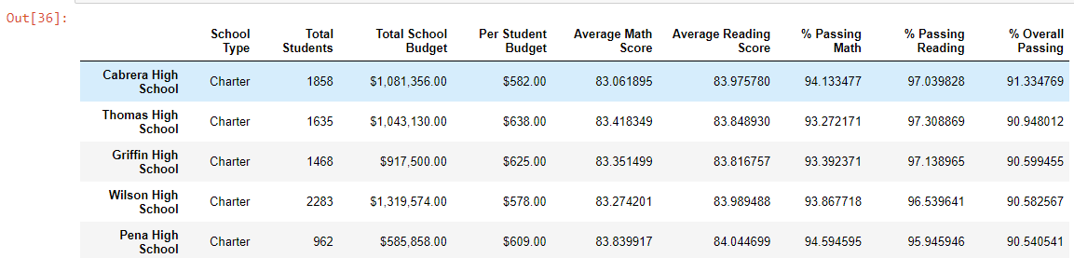

1. **Bottom Performing Schools (By % Overall passing)**

The table below shows the 5 bottom performing schools. They all are district school type. These 5 schools have the lowest percentage in overall passing rate, which are about 52-53%.

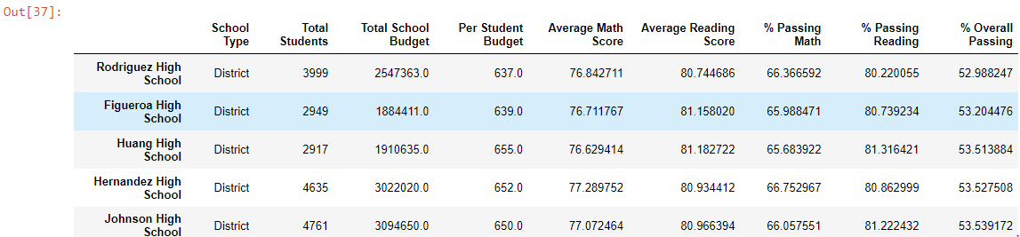

1. **Math Scores by Grade**

Students from charter schools score in math better than students from district school for all 9th grade to 12th grade.

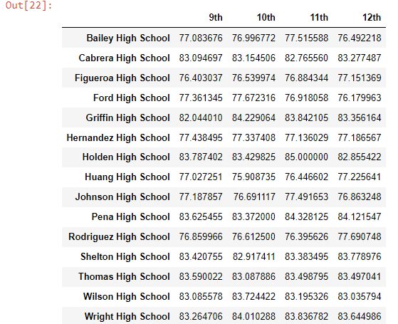

1. **Reading Scores by Grade**

Students from charter schools score in reading better than students from district school for all 9th grade to 12th grade.

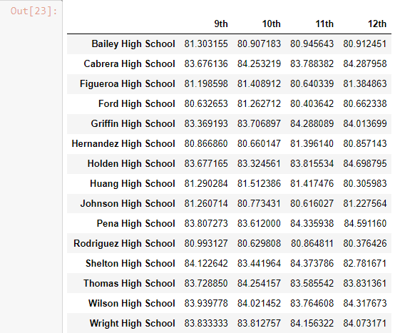

1. **Scores by School Spending**

The table below shows the breaks down school performance based on average spending ranges (per student). Schools with the lowest spending ranges per student (<$585) have the highest percentage overall passing. However, schools with the highest spending ranges per student ($645-680) have the lowest percentage overall passing.

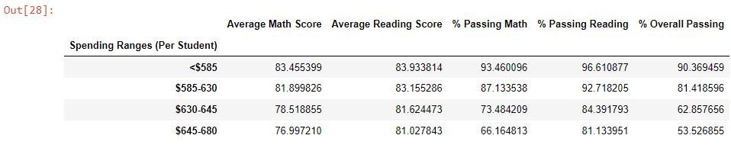

1. **Scores by School Size**

The table below summarizes school performance by school size. The medium size schools with 1,000 to 2,000 students are the schools with the highest percentage overall passing, 90.62. The small size schools with less than 1,000 students are the second rank in the percentage overall passing rate of 89.88%. Lastly, the large school size with 2,000 to 5,000 students are the school with the lowest percentage overall passing rate of 58.28%.

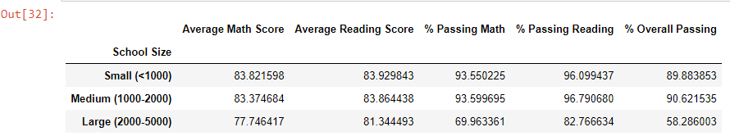

1. **Scores by School Type**

The table below summarizes the performance by school type. Comparing students’ performance from both school types, the result shows that students from charter school perform better than students from district school in both math and reading. As shown below, the percentage of passing math and passing reading of students from charter school is 93.62% and 95.58% respectively, while the percentage of passing math and reading of students from district school is 66.54% and 80.79% respectively.

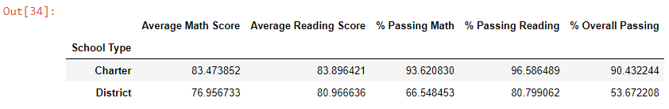

Analysis and Conclusion

In conclusion, students from charter schools perform better than students from district schools in all metrics for reading and math despite having less budget. One noticeable trend in this study is that, as the budget per student increases, the students’ average scores in both mat and reading, as well as percentage of passing math and reading and overall passing rate decreases.

Also, as the size of the school increase, the students’ performance drop. It can be implied that the size of the school has a significant impact on students’ performance. The larger the size of the school, the lower the students’ passing rate. In order to improve the students’ performance, the district may need to restructure the school size or student per class size. Student in smaller group perform better because they can receive more attention from teachers.

The top 5 performing schools, which are all charter schools, have an overall passing rate at 90% while the bottom 5 schools, which are all district school, have an overall passing rate at 53%. The gap between the overall passing rate of the top 5 and the bottom 5 is very big. It can be implied that the quality of teaching in charter schools is better than in district schools.

Rodriguez High School is the lowest performing school despite having a relatively high spending budget per students. Student performance improvement is needed for those 5 bottoms perform district schools since the overall passing rate is only about 53%.

Additional study and research are needed in order to understand the reason why charter schools perform better than district schools.